DESIGN AND IMPLEMENTATION OF DRIVER DROWSINESS AND ALCOHOL INTOXICATION DETECTION USING RASPBERRY PI

Pandurang N. Kathar¹, Prof. D.L.Bhuyar²
P.G.Student Dept. of E&TC, CSMSS College of Engineering, Aurangabad (MS), India¹
Assistant Professor, Dept. of E&TC, CSMSS College of Engineering, Aurangabad (MS), India²

Abstract
Drowsiness and drunken driving are noticeable causes for road accidents. In this paper we propose a real time detection for driver’s drowsiness as well as alcohol intoxication and subsequent alerting System. The primary aim of this proposed system is to bring reduction in the number of road accidents caused due to driver’s Drowsiness and alcohol intake, to facilitate an increase in the transportation safety. Our proposed system contains 8-megapixels digital USB camera, Raspberry-pi loaded with Raspbian-OS. Alcohol sensor (MQ-3) is used to detect the intake of alcohol in percentage, if the intoxication matching fails, alarm gets triggered on and GSM transmits a warming message. The Raspberry-pi system board is serially interfaced with Arduino Uno. GSM, Bluetooth, relay circuitry and buzzers are interfaced with Arduino Uno to alert driver through alarm notification and switching off the car power source.

Keywords: Drowsiness detection, Alcohol intoxication, Raspberry pi, Arduino UNO, OpenCv, and GSM

*Author for Correspondence E-mail: mailid@author, Tel:

INTRODUCTION
Most of the road accidents are caused because of drowsiness and drunk driving, rough working environments, reduced sleep and long working hours. Driver drowsiness and fatigue drunk driving reduces the driver decision making capability and decreases perception level. Both the situations affect the ability to control the vehicle and alert decision making. There are few techniques which are used to detect drowsiness in drivers like sensing driver operation or physiological characteristics of driver or by vehicle movement etc. Traffic survey’s show that driver fatigue may be a contributory factor in up to more than 20% and due to alcohol drinking it is about 31% of all road accidents [1].The primary purpose of our drowsiness and alcohol detection system is to develop a system that can reduce the number of accidents from drowsiness and drunk driving of vehicle.[2] the first part of the this project is detecting drowsiness, for that we use a camera for detecting image or face, Eye detection is the important part of this project which is done using [3]OpenCV. [4]The Input 8 megapixel camera, which is capable of capturing real time images and video. The captured video frame is processed on Raspberry pi. Drowsiness detection algorithm is implemented using Python.[5] Eye close detection is based on Haar cascade classifier and canny edge detection technique and performs several comparisons from a database of positive value and negative value of images and returns a red border rectangle over the detected area on matching. [7][8]Eye closing rate is calculated after each 8 seconds, after crossing a predefined threshold value, the Raspberry pi sends a high pulse signal serially to its slave device Arduino Uno. On receiving the high pulse signal, the arduino performs a set of tasks like Alarm by buzzer or send message to its car owner.[9][10]On the other hand alcohol sensor (MQ-3) works as a breathalyzer and calculate blood alcohol content (BAC) from breath alcohol content (BrAC).The arduino is interface with MQ-3, Bluetooth, buzzer and relay. Arduino continuously checks alcohol content present in the air and also computes blood alcohol content in Percentage from it. [11] If the calculated %BAC crosses the threshold limit, it will instantaneously give alarm through buzzer and will turn off the relay and hence the moving vehicle. If drunk limit crosses over, then a message is sent through GSM to the car owner.

MATERIALS AND METHODS

System hardware and Configuration

- Software Configuration
In our proposed system there are some necessary software tools required for the system includes Raspbian operating system, Python IDLE and Compiler, Open CV, Computer vision library extension for python with Haar cascade classifier and object detection, Canny edge detector, Arduino IDE and programmer for alcohol sensors and corresponding outputs and AT commands are used for GSM modem for messaging purpose.

B. Hardware Modules
i) Raspberry Pi Board
Raspberry Pi (represented in Figure.1) is a credit card sized single-board computer. Generation 2 Model B also has 4 USB ports, 1 GB RAM, USB camera interface and 1HDMI interface and 40 GPIO allows us to control and interact with real world.

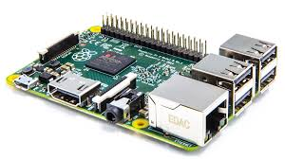

Fig. 1. Raspberry pi2 model B.

We implemented system using raspberry pi2 Model B. IT has a Broadcom BCM2836 system on chip which includes an ARM1176JZF-S 900 MHz processor, Video Core IV GPU, and an SD card. The GPU is capable of Blu-ray quality playback, using H.264 at 40MBits/s. It has a fast 3D core accessed using the supplied Open GL ES2.0 and Open VG libraries. The chip specifically provides HDMI and there is no VGA support. The foundation provides Debian and Arch Linux ARM distributions and also Python as the main programming language, with the support for BBC BASIC, C and Perl.

ii) Arduino UNO development board
In Arduino Uno (represented in Figure.3),"Uno" means one in Italian and is named to mark the upcoming release of Arduino 1.0 version. The Arduino Uno is a microcontroller board based on the ATmega328. It has 14 digital input/output pins (of which 6 can be used as PWM outputs), 6 analog inputs, a 16 MHz crystal oscillator, a USB connection, a power jack, an ICSP header, and a reset button. It contains everything needed to support the microcontroller; simply connect it to a computer with a USB cable or power it with a AC-to-DC adapter or battery to get started. The Uno differs from all preceding boards in that it does not use the FTDI USB-to-serial driver chip. Instead, it features the Atmega8U2 programmed as a USB-to-serial converter.

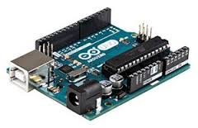
Fig.2. Arduino UNO development board
iii) Camera Interface
The USB camera module (shown in the Figure 4) used in this project. The camera plugs directly into the USB connector on the Raspberry Pi. It's able to deliver clear 8MP resolution image, or 1080p HD video recording at 30fps. This USB camera which has no infrared filter making it perfect for taking infrared photographs or photographing objects in low light (twilight) conditions.

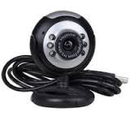
Fig.3. USB camera
iv) GSM Modem (SIM900)

In this system GSM is used, operating frequency of GSM lies in between 900MHz and 1.8GHz bands. One of the most leading digital systems is GSM. GSM uses narrow band Time Division Multiple Access (TDMA). Of all time GSM becomes the world's fastest growing communications technology. It is the leading global mobile standard. GSM is an open, digital cellular technology, which is used for transmitting both data services and mobile voice .The GSM is able to support data transfer speeds of up to 9.6 kbps. It also allows the transmission of basic data services such as SMS.

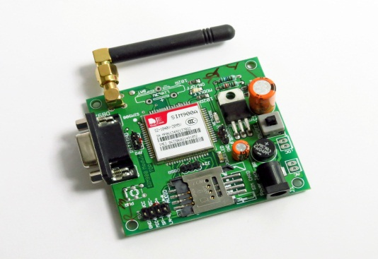

Fig.4. GSM Modem (SIM900)

v) Alcohol Sensor (MQ-3)

The alcohol sensor will detect the alcohol depends on human breath i.e. if the driver has consumed alcohol, it will be identified by his breath, and the sensor will display on the LCD regularly. The sensor is placed in front of the driver.

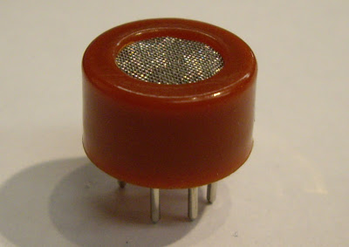

Fig.5. MQ-3 alcohol gas sensor

The alcohol sensor MQ-3 is selected in this system due to its high sensitivity in detection and has good resistance to disturb of gasoline, smoke and vapor. The sensor able to detect BAC with different concentration and classified the range of BAC detected into a few level. The alcohol sensor MQ-3 is a heater-driven alcohol gas sensor, its output is an analog signal which measures alcohol content. It is used measure the present of alcohol in the volume of breath in mg/L (milligrams per liter). These are also known as Breathalyzer or breathe content (BrAC).we can determine the driver consumed alcohol or not by the percent of BAC in blood of driver.
MQ BrAC values can be converted to
BAC.0.1% BAC = 1000 mg/L

Methodology
In this section results are obtained using software and hardware platforms to achieving the objective of driver drowsiness detection and alcoholic intoxication. Besides eye and head movements, another visual cue that can potentially capture one’s level of drowsiness is his/her eyes and faces detection analysis. Making a real time application with computer vision is very effective and efficient challenging task that needs processing powerful system. OpenCV is open source software, which is library used for working with Computer Vision. OpenCV is available as wrapper for C, C++, and Python and Java programming languages extension. Raspberry controller small sized ARM 11 open source controller with the GPU provides up to 1.5Gpixels of graphics processing and processing700 MHz It can be over clocked maximum 1500MHz Raspberry-pi can work with Raspbian operating system, which is a light weight Linux. Raspbian OS is loaded with programming software and OpenCV. It supports interfacing of various low level and high level peripherals including USB camera and GPIO’s. In case of driver is in sleepy or finding fatigue, the message will be sent by using GSM and buzzer will be turned on till the GSM positive message from car owner. Fig. 1 shows the basic block diagram of the proposed system. Haar Feature based Cascade Classifier technique, it is a machine learning based approach where a cascade function is trained from a lot of positive and negative images, and this positive image is used for detecting face region and eye region the update of region of interest ROI. Open CV is packed with a trainer as well as detector. The open CV is used for creating user defined object classifier. The object classifier that has been created is stored in.xml file extension classifier can be used in the later stages of programming. Also in this paper we use canny operator edge detection for recognize exact coordinate of eyes region. On the other hand of the system arduino is used for detection of the alcohol consumption by the person, alcohol gas sensor or breathalyzer MQ-3 is interfaced. Arduino will detect samples of the person who is driving drunk or not. Based on the output from arduino, an alarm will be turned on and the car’s ignition power source can be cut down through a relay to stop the car or preventing the driver to start the car. If driver is in over drunk then the message will be sent by using GSM and buzzer will be turned on till the GSM positive message from car owner.

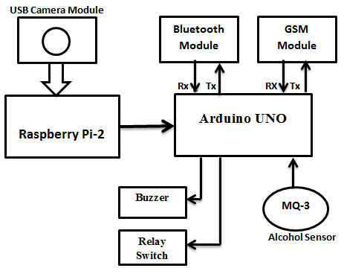

Fig.6. Block diagram of the proposed system.

RESULTS

This proposed system is still in research level and integrated into few high end cars, for measuring accuracy of the proposed system and algorithm. The USB camera connected to Raspberry pi which is loaded with Raspbian O.S and Python with OpenCV. The detection algorithm can detect image of driver through camera, face region is marked with green rectangle, the region of interest that shows the eye region is marked with red color rectangle.

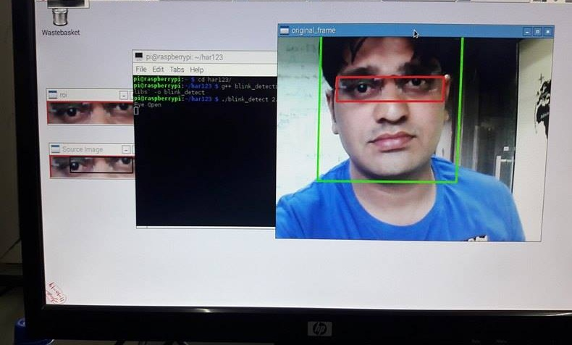

Fig.7. Detection of face, open eye detection.
In the next Figure, eyes of the person are closed, hence eyes closed are detected with a red rectangular frame by the system. If the closed eyes frame is detect for more than 5 frames in a program, an instantaneous warning alarm through buzzer is generated. In other condition if closed eyes frames are more than threshold value of 10 frames, the system transmit a pin high of the Raspberry Pi GPIO’s which is serially interface with Arduino UNO and a message is sent through GSM Modem.

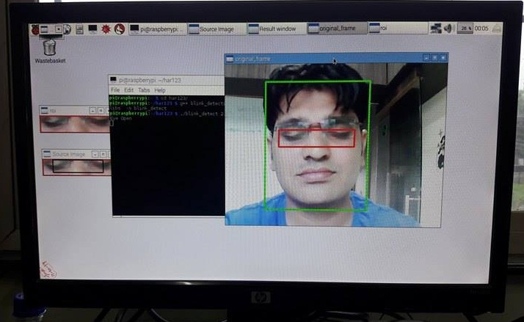

Fig.8. Detection of face, Closed Eyes detection.

In order to detect the Alcoholic Intoxication of the driver, an alcohol gas sensor (MQ3) work as a Breathalyzer to calculate alcohol intake of the driver. The testing and Observation of MQ-3 Alcohol sensor is based on the Arduino UNO programming. At the time of testing of MQ-3 Alcohol sensor there are different voltages level/samples at output. The sensor continuously variation in the range of between 0-1023, because there is 10bit ADC output. In this system is the alcoholic Intoxication is displayed in the percentage, for that purpose we program as per our condition that voltage samples is converted into percentage using Mapping Diagram Concept. If the input of alcohol is 0% to 60% at the time, output is in the form of a buzzer Indication to the Driver. If the input of alcohol is above 70% at the current time, GSM modem gets activated through Arduino UNO and a message is sent to the car owner as well as the Ignition of the car is switched off through relay switch to prevent drunk driving.
The system begins to operate when the alcohol sensor detected BAC level from the driver. Then it will send the signal to Arduino UNO for further process which will involve the LCD display, alarm and ignition system. BAC level detected by alcohol sensor is based on gas or alcohol concentration in ppm (parts per million). This system is tested by Whisky alcoholic drinks / after shave lotion as the input to the experiment. The alcohol sensor can sense an alcohol from human breath from 0 ppm until 1000 ppm. The result is categorized into four conditions of the driver with different value (in percentage) of BAC level which are intoxication, slightly drunk, drunkenness and over limit drunk.
Table 1 shows the achieved result. Table 1: Result achieved in different level of drunkenness in ppm for first condition, LCD will display “intoxication” when the alcohol sensor detected BAC level from 0% to 20%. This condition showed that the driver is free from alcohol and there is no alarm sound from the buzzer is activated. While the ignition system is enable means the driver is conscious and can drive the vehicle on the road safely. The next condition is slightly drunk with 21% to 40% drunkenness level. This means the driver has drunk with a little amount of alcohol, but need to be assisted during the driving on the road. The buzzer is activated to alert the driver and the people in vicinity that the driver is slightly drunk. The third condition drunkenness level with 41% to 60%. This means the driver has drunk with a little strong amount of alcohol, but need to be assisted during the driving on the road. The buzzer is activated to alert the driver and the people in vicinity that the driver is slightly drunk. In the last condition, the ignition system is deactivated as the level of BAC is too high. The driver is totally unconscious and not safe for driving. Figure 6 show the corresponding value of BAC in ppm to the alcohol sensor output voltage. Ultimately, this system help to prevent the driver to drive in risky situation and will avoid accident occur on the road

Table 1: Result achieved in different level of drunkenness in ppm

Output | Level Of Drunkenness
Output | 0% -20% | 21%-40% | 41%-60% | 61%-99%
LCD Display | “Intoxication” | “Slightly Drunk” | “Drunkenness” | “Over limit drunk”
Buzzer Indication | OFF | OFF | ON | ON
Ignition System | Enable | Enable | Enable | Disable
Message Send by GSM | NO | No | NO | YES

Table 2: Output voltages for the MQ-3 alcohol sensor circuit

No. of Samples | Operating Voltage of MQ-3 Sensor | ALCOHOL SENSOR MQ-3 OUTPUT SAMPLES IN PPM
No. of Samples | Operating Voltage of MQ-3 Sensor | 0%-10% | 11%-20% | 21%-30% | 31%-40% | 56%-60% | Above 60%
No. of Samples | Operating Voltage of MQ-3 Sensor | Red Line | Sky Blue | Green | Yellow | Blue | Black
1 | 0 v | 0 | 0 | 0 | 0 | 0 | 0
2 | 0.5 v | 0 | 22 | 82 | 76 | 163 | 213
3 | 1 v | 30 | 30 | 98 | 102 | 332 | 312
4 | 1.5 v | 35 | 98 | 193 | 196 | 556 | 619
5 | 2 v | 52 | 115 | 223 | 234 | 623 | 782
6 | 2.5 v | 66 | 135 | 283 | 294 | 762 | 886
7 | 3 v | 79 | 142 | 297 | 315 | 782 | 889
8 | 3.5 v | 91 | 147 | 297 | 317 | 784 | 889
9 | 4 v | 93 | 148 | 297 | 317 | 785 | 889
10 | 4.5 v | 98 | 150 | 297 | 319 | 790 | 893
11 | 5 v | 98 | 155 | 299 | 319 | 792 | 894

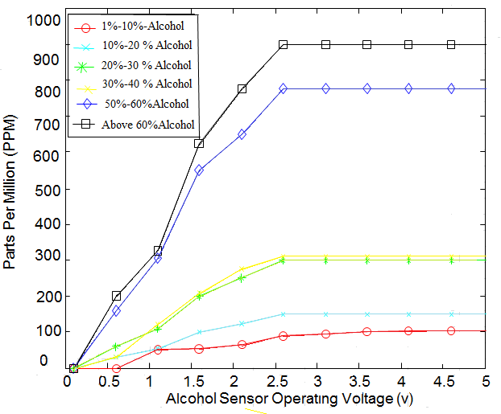
Graph 1: Response of ppm (In Percentage) via alcohol sensor output voltages values

CONCLUSIONS
In our Research, we have presented the application of computer vision with embedded systems targeted for reducing road accidents due to driver drowsiness and alcoholic intoxication. We are monitoring and detecting the driver’s behavior to ensure road safety and avoid road accidents. It is important to capture driver behavior which will reduce the accidents due to rash driving under the influence of alcohol. The proposed system deals with detection of Alcohol and Drowsiness using sensors and accordingly precautions are taken. To get the notification message with help of GSM modules. The system works well even in case of drivers wearing spectacles and under low light conditions also. Development of software algorithm is completed which is partially tested and found successfully working.

ACKNOWLEDGMENTS
Acknowledgments recognize the contribution of funding bodies and anyone who has assisted in the work.

REFERENCES

Journal Articles
- Dwipjoy Sarkar and Atanu Chowdhury, “A Real Time Embedded System Application for Driver Drowsiness and Alcoholic Intoxication Detection”, International Journal of Engineering Trends and Technology (IJETT), Volume 10, Number 9, Apr, pp. 461-465, 2014.
- T.D Prasanthi,K.Rajasekhar,T.V.Janardhana rao,and B.V.V.satyanarayana,”Design of ARM based face Recognition system using Open CV library”, International Journal of Advanced Research in Computer & Technology(IJARCET),Volume 01,Issue-9,pp-233-240, 2012
- Varsha.E.dahiphale and Prof.sathyanarayana R,”Computer Vision System for Driver Fatigue Detection”, International Journal of Advanced Rsearch in Electronics and communication Engineering(IJARECE), volume 04,Issue-9, pp-2331-2334, 2015.
- Saeid.fazli and Parisa .Esfehani,”Tracking Eye State for Fatigue Detection”, International Conference on advanced in Computer and Electrical Engineering (ICACEE’2012), pp-17-18, 2012
- Lorraine Saju, Christeena Jestine, Farhana Yasmin, and Surekha Mariam Varghese, “Drowsiness Detection System for Drivers using Haartraining and Template Matching”, International Journal of Engineering Applied Sciences and Technology, Vol. 1, Issue 6, pp. 106-110, April - May 2016.
- Dhaval Pimplaskar,Dr.M.S.Nagmode,Atul Borkar,”Real Time Eye Blinking Detection and Tracking Using OpenCV”,International Journal of Engineering Research and Application,Vol.03,Issue 05,PP-1780-1787, 2013
- Naveen M. and Sudarvizhi S., “Finger Vein Recognition Based Driver Authentication and Alertness System Using GSM”, International Journal of Research in Engineering & Advanced Technology (IJREAT), Volume 3, Issue 1, pp.211-216, 2015
- Srinivasu Batchu and S. Praveen Kumar, “Driver Drowsiness Detection to Reduce the Major Road Accidents in Automotive Vehicles”, International Research Journal of Engineering and Technology (IRJET), Volume 02, Issue 01, pp. 345-349, 2015
- L.Nikitha,J.Kiranmai,B.Vidhyalakshmi,”Driver Behaviour Analysis Using Non-Invasive sensors”, International Journal of Advance in Engineering and Science(IJATES),Volume 03,Issue 01, pp 707-714, 2015
- Prof.Saurabh Thakur, Shekhar Dure, Ajinkya Khutwad,”Advance Vehicle Control and Safety System Using Face Detection”, International Journal of Advance Research In Science And Engineering (IJARSE),Vol.No.4,Issue 05,pp.141-146, 2015
- Ashutosh U.Jadhav and N.M.Wagdarikar,”Intelligent Vehicle System for Driver Assistance”, International Journal of Advance Research In Electrical, Electronics And Instrumentation Engineering(IJAREEIE),Vol.No.4,Issue 07,pp.6616-6623, 2015

